**SPH3U 9.4 Damping and Resonance**

1. **Damping and resonance**

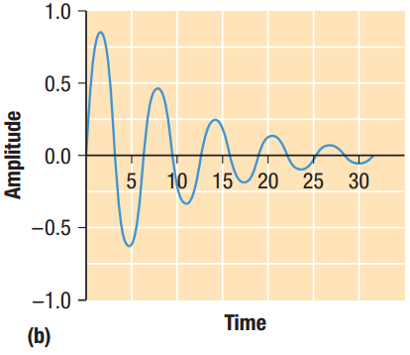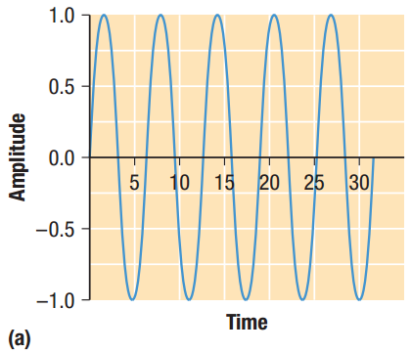

|  |  |
| --- | --- |
| Damping: |  |
| Resonant frequency: |  |
| resonance |  |
| standing waves |  |
| Vibrating structures: |  |

**Homework:** page 432: #1-2